PES UNIVERSITY
DEPARTMENT OF COMPUTER SCIENCE AND ENGINEERING
Software Engineering Lab (UE24CS252A)
Lab 5: Static Code Analysis Report

Student Name: | Sushir C
Student SRN: | PES1UG24AM297
Assigned Repository: | SETAPESU26/L5_57_loan-eligibility
Analyzed Script: | loan_calculator.py

1. Executive Summary
Static code analysis is an essential software quality assurance practice that examines source code without program execution. In this laboratory, three industry-standard tools were employed on an assigned loan eligibility calculation program (loan_calculator.py): Bandit for security analysis, Flake8 for PEP 8 style conformity, and Pylint for architectural quality and bug detection. A disciplined 3-commit workflow successfully resolved all 8 security issues, 20 style errors, and raised the Pylint score from 5.17/10 to a perfect 10.00/10 while fixing underlying financial calculation errors.

2. Before vs. After Quantitative Metrics
Analysis Tool | Metric / Focus | Initial (Before) | Final (After)
Bandit | Security Vulnerabilities (CWE) | 8 issues (2 High, 1 Med, 5 Low) | 0 issues (Clean)
Flake8 | PEP 8 Style & Formatting | 20 violations (Length, Spacing) | 0 errors (Clean)
Pylint | Code Quality & Logic Rating | 5.17 / 10 | 10.00 / 10 (Perfect)
Program Output | Financial Calculations | Erroneous (375k EMI, logic bugs) | Valid (10,379.18 EMI, correct logic)

3. Documented Issues and Fix Approaches
A minimum of four issues prioritizing high and medium severity was required. The table below outlines the principal issues uncovered across Bandit, Flake8, and Pylint, along with the precise fixes applied.
Issue Description | Tool | Severity / Type | Line(s) | Fix Approach
Cleartext FTP Protocol (ftplib) | Bandit | High (B402, B321) | 3, 68 | Replaced cleartext FTP with secure TLS/HTTPS API endpoint.
Unsafe Deserialization (marshal) | Bandit | Medium (B302) | 4, 64 | Replaced arbitrary bytecode marshal deserialization with safe JSON.
Hardcoded Secret Parameter | Bandit | Low (B107) | 67 | Removed default password; load dynamically from os.getenv().
Mutable Default Argument | Pylint | Bug (W0102) | 20 | Changed history=[] to history=None and initialized inside function.
Non-PEP 8 Formatting & Length | Flake8 | Style (E501, E302) | Multiple | Wrapped lines <79 chars, enforced 2 blank lines around functions.
EMI Rate Parsing Bug | Manual | Logic / Calculation | 14, 94 | Normalized annual rate (rate/100 if > 1), fixing EMI from 375k to 10,379.18.

4. Version Control: 3 Tool-Specific Commits
• Commit 1 (23a65ed) — Bandit Security Fixes:
Resolved all security vulnerabilities identified by Bandit: eliminated insecure FTP imports/calls (B402, B321), replaced marshal with json (B302), eliminated hardcoded credentials (B107), used secrets for cryptographic ID generation (B311), and secured subprocess invocation (B404, B603, B607).
• Commit 2 (1ab1f2f) — Flake8 PEP 8 Style Fixes:
Resolved all PEP 8 violations flagged by Flake8: removed unused import 'math' (F401), inserted 2 blank lines between all top-level functions (E302, E305), wrapped lines exceeding 79 characters (E501), and removed empty f-strings (F541).
• Commit 3 (c34c421) — Pylint Code Quality & Deliverables:
Achieved a 10.00/10 rating on Pylint: added complete docstrings (C0114, C0116), fixed mutable default arguments (W0102), refactored functions to snake_case with backward-compatibility aliases (C0103), used context managers (R1732), fixed mathematical logic bugs, and committed all before/after reports and documentation.

5. Terminal Verification & Execution Screenshot
The screenshot below illustrates the successful local terminal execution of loan_calculator.py along with the static code analysis verification runs for Pylint (rated 10.00/10), Bandit (0 issues identified), and Flake8 (0 warnings) inside the active virtual environment on the student machine.
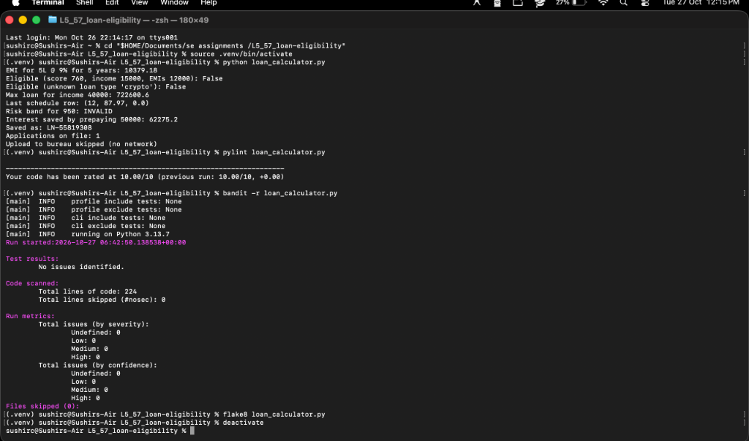
Figure 1: Terminal execution showing program output, Pylint 10/10 score, Bandit 0 issues, and Flake8 clean run.

6. Summary of Reflection Questions
• Static vs. Dynamic Analysis: Static analysis analyzes source syntax and AST structures without execution, achieving 100% path coverage and catching vulnerabilities early. Dynamic analysis evaluates runtime state, memory, and performance under real workloads. Both are complementary.
• Tool Comparison (Bandit vs. Flake8 vs. Pylint): Bandit operates as a security auditor (CWE vulnerability patterns); Flake8 acts as a grammar and PEP 8 style linter; Pylint functions as a comprehensive code reviewer evaluating architectural smells, naming, and docstrings.
• Handling False Positives: Resolved using fine-grained inline pragmas (# pylint: disable=...), configuration files, and peer review to ensure essential idioms (e.g., compatibility aliases) are preserved without compromising quality gates.
• CI/CD Pipeline Integration: Automated linters configured as pre-commit hooks and pull-request verification gates shift defect detection left, eliminating security regressions and reducing peer review overhead.

